✅ Données chargées : (400000, 12)
Colonnes : ['shipment_id', 'product_id', 'supplier_name', 'origin_city', 'destination_city', 'ship_date', 'expected_delivery_date', 'actual_delivery_date', 'quantity', 'shipping_cost_ngn', 'logistics_company', 'delivery_status']

✅ Variables cibles créées : is_delayed (binaire) et delay_days (continu)
=== 1. STRUCTURE DU DATASET ===
• Nombre de lignes : 400,000
• Nombre de colonnes : 14
• Taille mémoire : 175.16 MB

=== 2. APERÇU DES DONNÉES ===
shipment_id product_id supplier_name origin_city destination_city \
0 SHIP0000000 PRD81347 Supplier_B Abuja Warri
1 SHIP0000001 PRD68757 Supplier_D Kano Jos
2 SHIP0000002 PRD34311 Supplier_E Lagos Port Harcourt
3 SHIP0000003 PRD14597 Supplier_D Lagos Ibadan
4 SHIP0000004 PRD98159 Supplier_D Lagos Enugu

ship_date expected_delivery_date actual_delivery_date quantity \
0 2024-03-23 2024-03-29 2024-03-27 828
1 2024-06-10 2024-06-21 2024-06-20 329
2 2024-10-15 2024-10-19 2024-10-18 203
3 2024-02-05 2024-02-19 2024-02-24 20
4 2024-03-31 2024-04-09 2024-04-14 465

shipping_cost_ngn logistics_company delivery_status is_delayed delay_days
0 18379.93 DHL Nigeria delayed 1 -2.0
1 91632.07 Fedex Nigeria delivered 0 -1.0
2 77141.08 Ace Couriers delivered 0 -1.0
3 69484.82 Kwik Delivery in_transit 0 NaN
4 47054.82 Kwik Delivery delivered 0 5.0

=== 3. TYPES DE DONNÉES ===
shipment_id object
product_id object
supplier_name object
origin_city object
destination_city object
ship_date datetime64[ns]
expected_delivery_date datetime64[ns]
actual_delivery_date datetime64[ns]
quantity int64
shipping_cost_ngn float64
logistics_company object
delivery_status object
is_delayed int32
delay_days float64
dtype: object

=== 4. STATISTIQUES DESCRIPTIVES (NUMÉRIQUES) ===
ship_date expected_delivery_date \
count 400000 400000
mean 2024-05-30 04:19:53.040000 2024-06-06 16:27:55.583999488
min 2024-01-01 00:00:00 2024-01-02 00:00:00
25% 2024-03-16 00:00:00 2024-03-24 00:00:00
50% 2024-05-30 00:00:00 2024-06-07 00:00:00
75% 2024-08-13 00:00:00 2024-08-21 00:00:00
max 2024-10-27 00:00:00 2024-11-10 00:00:00
std NaN NaN

actual_delivery_date quantity shipping_cost_ngn \
count 400000 400000.000000 400000.000000
mean 2024-06-08 04:27:16.055999488 504.906617 52547.524651
min 2023-12-31 00:00:00 10.000000 5000.290000
25% 2024-03-25 00:00:00 257.000000 28810.150000
50% 2024-06-08 00:00:00 505.000000 52634.390000
75% 2024-08-22 00:00:00 753.000000 76271.502500
max 2024-11-15 00:00:00 1000.000000 99999.530000
std NaN 286.132913 27410.200740

is_delayed delay_days
count 400000.000000 351870.000000
mean 0.080732 1.499594
min 0.000000 -2.000000
25% 0.000000 -1.000000
50% 0.000000 1.000000
75% 0.000000 4.000000
max 1.000000 5.000000
std 0.272424 2.292957

=== 5. STATISTIQUES DESCRIPTIVES (CATÉGORIELLES) ===
shipment_id product_id supplier_name origin_city destination_city \
count 400000 400000 400000 400000 400000
unique 400000 88943 5 4 15
top SHIP0000000 PRD37465 Supplier_B Lagos Onitsha
freq 1 17 80273 100521 26970

logistics_company delivery_status
count 400000 400000
unique 7 4
top Ace Couriers delivered
freq 57503 319577

=== 6. VALEURS MANQUANTES ===
delay_days 48130
dtype: int64

=== 7. LIGNES DUPLIQUÉES ===
Doublons : 0

Variables numériques : ['quantity', 'shipping_cost_ngn', 'is_delayed', 'delay_days']
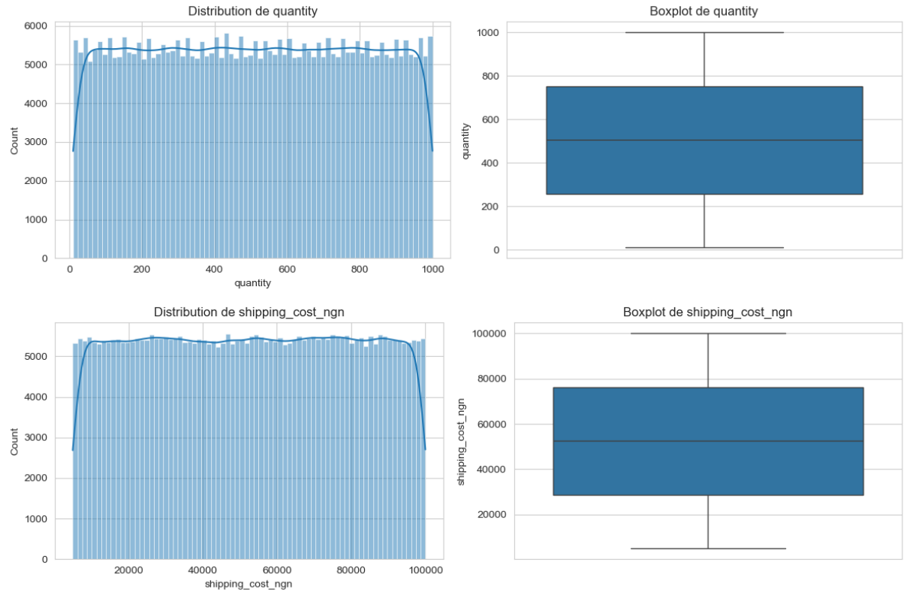
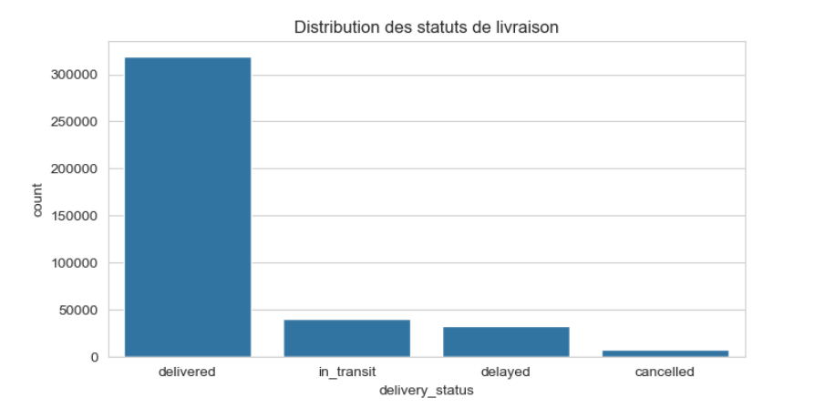
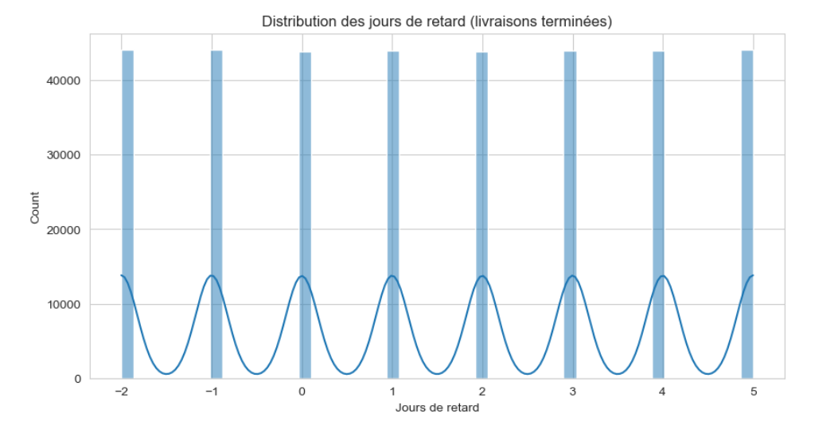
Variables catégorielles : ['shipment_id', 'product_id', 'supplier_name', 'origin_city', 'destination_city', 'logistics_company', 'delivery_status']

=== shipment_id : 400000 valeurs uniques ===
shipment_id
SHIP0000000 1
SHIP0266650 1
SHIP0266672 1
SHIP0266671 1
SHIP0266670 1
SHIP0266669 1
SHIP0266668 1
SHIP0266667 1
SHIP0266666 1
SHIP0266665 1
Name: count, dtype: int64

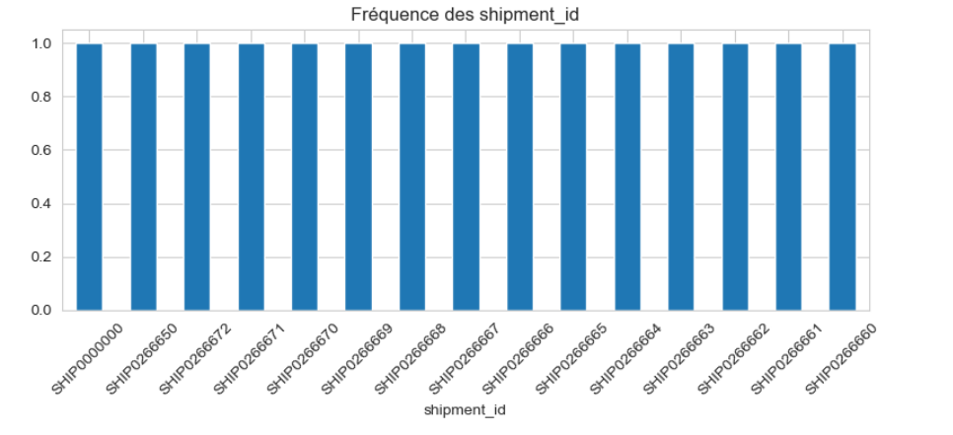
=== product_id : 88943 valeurs uniques ===
product_id
PRD37465 17
PRD90451 16
PRD45268 15
PRD58425 14
PRD54214 14
PRD87617 14
PRD72576 14
PRD77650 14
PRD93976 14
PRD97171 14
Name: count, dtype: int64
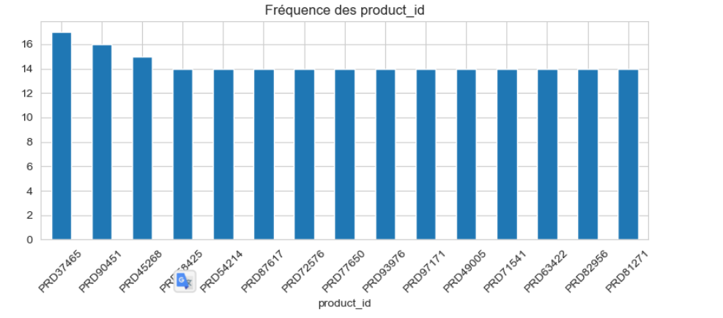
=== supplier_name : 5 valeurs uniques ===
supplier_name
Supplier_B 80273
Supplier_D 80050
Supplier_E 80019
Supplier_C 79859
Supplier_A 79799
Name: count, dtype: int64
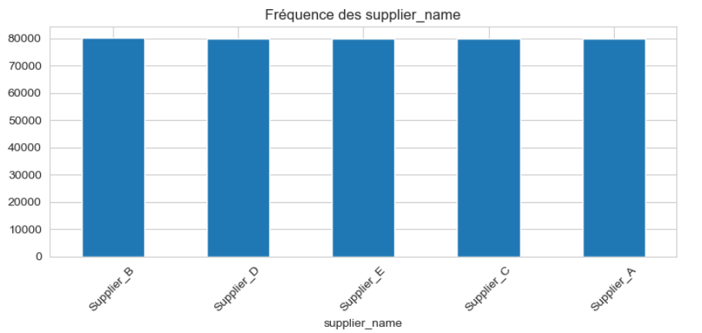
=== origin_city : 4 valeurs uniques ===
origin_city
Lagos 100521
Abuja 100228
Port Harcourt 99866
Kano 99385
Name: count, dtype: int64
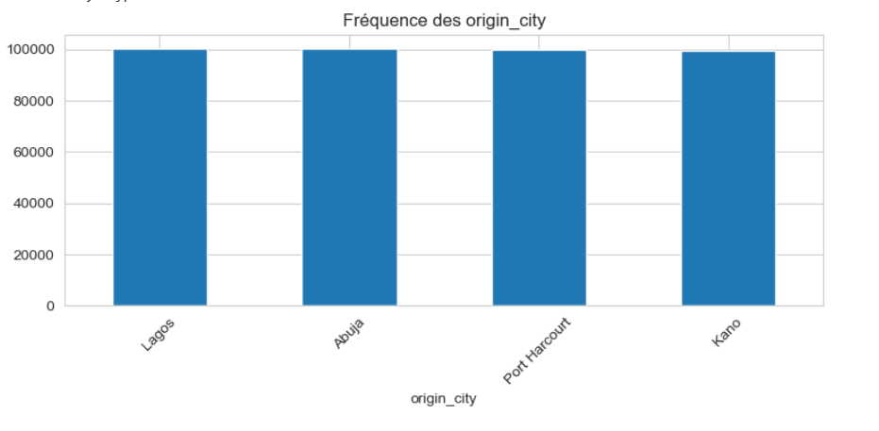
=== destination_city : 15 valeurs uniques ===
destination_city
Onitsha 26970
Aba 26945
Calabar 26898
Port Harcourt 26832
Enugu 26814
Warri 26708
Ibadan 26679
Kano 26633
Benin City 26604
Abuja 26604
Name: count, dtype: int64
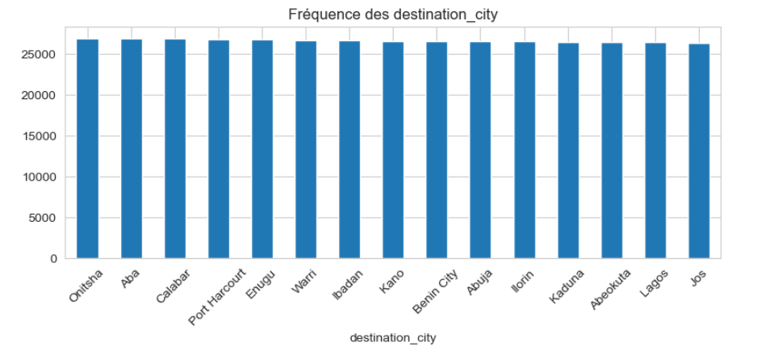

=== logistics_company : 7 valeurs uniques ===
logistics_company
Ace Couriers 57503
Kwik Delivery 57406
Fedex Nigeria 57238
GIG Logistics 57166
Red Star Express 57078
DHL Nigeria 56960
Dispatch Riders 56649
Name: count, dtype: int64
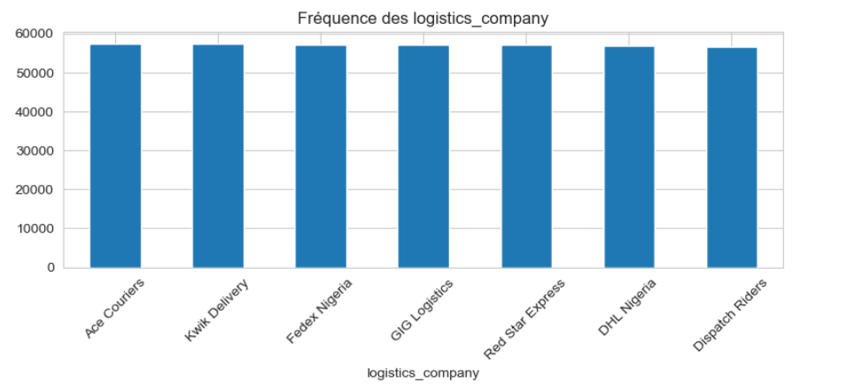
=== delivery_status : 4 valeurs uniques ===
delivery_status
delivered 319577
in_transit 40054
delayed 32293
cancelled 8076
Name: count, dtype: int64
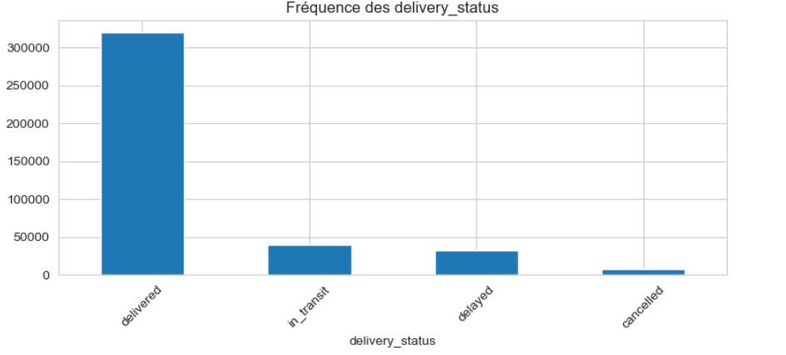
=== Corrélations avec is_delayed ===
is_delayed 1.000000
quantity 0.001345
delay_days -0.001444
shipping_cost_ngn -0.001710
Name: is_delayed, dtype: float64

=== Statistiques des variables numériques selon le retard ===

quantity :
count mean std min 25% 50% 75% \
is_delayed
0 367707.0 504.792574 286.005278 10.0 258.0 505.0 752.0
1 32293.0 506.205184 287.583506 10.0 256.0 505.0 758.0

max
is_delayed
0 1000.0
1 1000.0

shipping_cost_ngn :
count mean std min 25% \
is_delayed
0 367707.0 52561.415410 27410.571730 5000.29 28817.125
1 32293.0 52389.356335 27405.903916 5016.83 28711.420

50% 75% max
is_delayed
0 52641.78 76291.37 99999.53
1 52579.10 76038.38 99993.95

=== Taux de retard par variables catégorielles (top 5) ===

shipment_id (top 5) :
shipment_id
SHIP0000000 1.0
SHIP0349802 1.0
SHIP0349799 1.0
SHIP0250816 1.0
SHIP0054568 1.0
Name: is_delayed, dtype: float64

product_id (top 5) :
product_id
PRD84650 1.0
PRD17462 1.0
PRD92327 1.0
PRD63031 1.0
PRD42999 1.0
Name: is_delayed, dtype: float64

supplier_name (top 5) :
supplier_name
Supplier_B 0.082705
Supplier_A 0.081191
Supplier_D 0.080375
Supplier_E 0.080368
Supplier_C 0.079014
Name: is_delayed, dtype: float64

origin_city (top 5) :
origin_city
Kano 0.082014
Abuja 0.080556
Port Harcourt 0.080418
Lagos 0.079953
Name: is_delayed, dtype: float64

destination_city (top 5) :
destination_city
Abeokuta 0.082445
Calabar 0.082385
Benin City 0.082131
Kaduna 0.082044
Warri 0.081848
Name: is_delayed, dtype: float64

logistics_company (top 5) :
logistics_company
Ace Couriers 0.081596
Kwik Delivery 0.081525
Red Star Express 0.081520
Fedex Nigeria 0.081100
GIG Logistics 0.080940
Name: is_delayed, dtype: float64

delivery_status (top 5) :
delivery_status
delayed 1.0
cancelled 0.0
delivered 0.0
in_transit 0.0
Name: is_delayed, dtype: float64

=== Taux de retard par couple origine-destination (échantillon) ===
destination_city Aba Abeokuta Abuja Benin City Calabar \
origin_city
Abuja 0.041176 0.088757 0.063291 0.086957 0.078652
Kano 0.052326 0.078947 0.036145 0.077844 0.048780
Lagos 0.111765 0.083871 0.067416 0.082353 0.077381
Port Harcourt 0.045161 0.105882 0.037037 0.062147 0.038217

destination_city Enugu Ibadan Ilorin Jos Kaduna Kano \
origin_city
Abuja 0.075581 0.089655 0.097561 0.086207 0.111111 0.074713
Kano 0.080000 0.053571 0.073171 0.070423 0.054878 0.088435
Lagos 0.058065 0.111650 0.065476 0.081522 0.076923 0.071429
Port Harcourt 0.067416 0.064516 0.071856 0.098446 0.106918 0.078534

destination_city Lagos Onitsha Port Harcourt Warri
origin_city
Abuja 0.111111 0.078014 0.089820 0.109827
Kano 0.077348 0.081250 0.105590 0.092486
Lagos 0.116564 0.095808 0.062112 0.085859
Port Harcourt 0.087838 0.073529 0.122093 0.092715
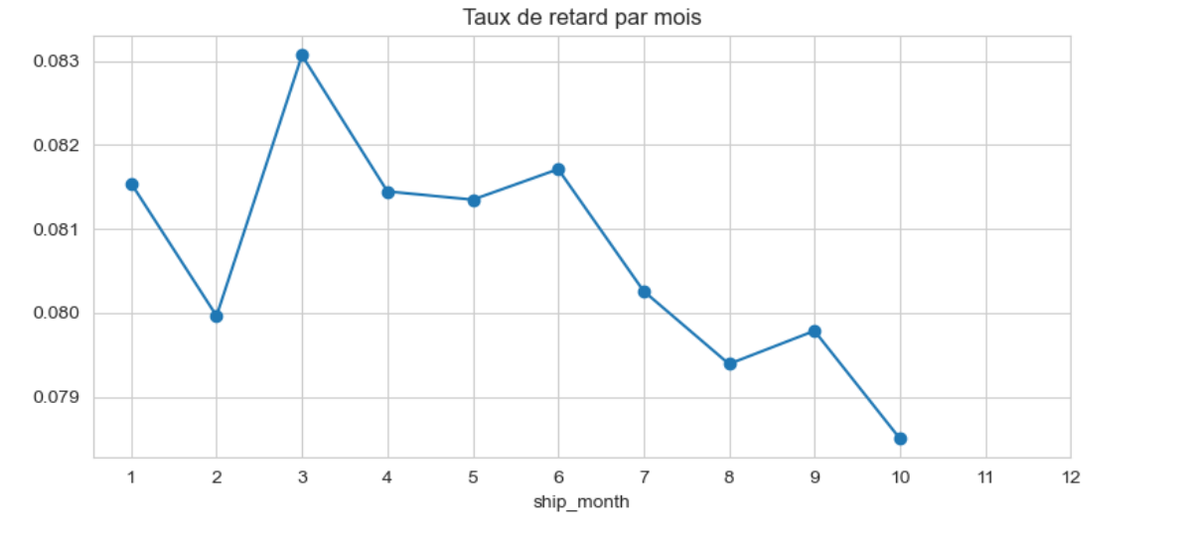
=== Détection des outliers (IQR) ===
quantity : 0 outliers (0.00%)
shipping_cost_ngn : 0 outliers (0.00%)
=== Asymétrie (skewness) des variables numériques ===
quantity : 0.000
shipping_cost_ngn : -0.003

=== SYNTHÈSE DE L'EDA ===
- Aucune valeur manquante dans les colonnes d'origine.
- 0 doublons.
- Variables numériques : quantity et shipping_cost_ngn ont des distributions symétriques (skewness ~0).
- Variable cible is_delayed : 8% de retards (déséquilibre à prendre en compte).
- Variables catégorielles bien réparties.
- Les boxplots ne montrent pas d'outliers extrêmes.
- Relations observées :
* Le coût de livraison semble légèrement plus élevé pour les livraisons retardées.
* Certains prestataires logistiques présentent des taux de retard plus élevés.
* Les mois de l'année influencent le taux de retard (saisonnalité).
* Les couples origine-destination affichent des disparités.

Recommandations pour la suite :
1. Conserver les variables brutes (pas de transformation log).
2. Créer des features temporelles (mois, jour de semaine, saison, délai prévu).
3. Intégrer des données géographiques (distance, région) pour enrichir le modèle.
4. Gérer le déséquilibre de la classe 'is_delayed' lors de la modélisation.
5. Envisager une normalisation des variables numériques pour les modèles linéaires.
Valeurs manquantes avant traitement :
shipment_id 0
product_id 0
supplier_name 0
origin_city 0
destination_city 0
ship_date 0
expected_delivery_date 0
actual_delivery_date 0
quantity 0
shipping_cost_ngn 0
logistics_company 0
delivery_status 0
is_delayed 0
delay_days 48130
dtype: int64
quantity : 0 outliers (0.00%)
shipping_cost_ngn : 0 outliers (0.00%)
Doublons : 0
Données nettoyées sauvegardées dans 'supply_chain_cleaned.csv'
Dimensions finales : (400000, 14)
Valeurs manquantes après feature engineering :
quantity 0
shipping_cost_ngn 0
is_delayed 0
delay_days 48130
planned_delay 0
ship_month 0
ship_dayofweek 0
ship_quarter 0
ship_season 0
origin_population 199613
dest_population 239947
distance_km 320012
product_freq 0
product_avg_qty 0
product_avg_cost 0
product_avg_planned_delay 0
product_delay_rate 0
supplier_name_le 0
origin_city_le 0
destination_city_le 0
logistics_company_le 0
origin_region_le 0
dest_region_le 0
supplier_name_Supplier_B 0
supplier_name_Supplier_C 0
supplier_name_Supplier_D 0
supplier_name_Supplier_E 0
origin_city_Kano 0
origin_city_Lagos 0
origin_city_Port Harcourt 0
destination_city_Abeokuta 0
destination_city_Abuja 0
destination_city_Benin City 0
destination_city_Calabar 0
destination_city_Enugu 0
destination_city_Ibadan 0
destination_city_Ilorin 0
destination_city_Jos 0
destination_city_Kaduna 0
destination_city_Kano 0
destination_city_Lagos 0
destination_city_Onitsha 0
destination_city_Port Harcourt 0
destination_city_Warri 0
logistics_company_DHL Nigeria 0
logistics_company_Dispatch Riders 0
logistics_company_Fedex Nigeria 0
logistics_company_GIG Logistics 0
logistics_company_Kwik Delivery 0
logistics_company_Red Star Express 0
origin_region_Rivers 0
dest_region_Kaduna 0
dest_region_Lagos 0
dest_region_Rivers 0
dtype: int64
Jeu final avec features sauvegardé dans 'supply_chain_featured.csv'
Dimensions finales : (400000, 54)
Colonnes disponibles : ['quantity', 'shipping_cost_ngn', 'is_delayed', 'delay_days', 'planned_delay', 'ship_month', 'ship_dayofweek', 'ship_quarter', 'ship_season', 'origin_population', 'dest_population', 'distance_km', 'product_freq', 'product_avg_qty', 'product_avg_cost', 'product_avg_planned_delay', 'product_delay_rate', 'supplier_name_le', 'origin_city_le', 'destination_city_le', 'logistics_company_le', 'origin_region_le', 'dest_region_le', 'supplier_name_Supplier_B', 'supplier_name_Supplier_C', 'supplier_name_Supplier_D', 'supplier_name_Supplier_E', 'origin_city_Kano', 'origin_city_Lagos', 'origin_city_Port Harcourt', 'destination_city_Abeokuta', 'destination_city_Abuja', 'destination_city_Benin City', 'destination_city_Calabar', 'destination_city_Enugu', 'destination_city_Ibadan', 'destination_city_Ilorin', 'destination_city_Jos', 'destination_city_Kaduna', 'destination_city_Kano', 'destination_city_Lagos', 'destination_city_Onitsha', 'destination_city_Port Harcourt', 'destination_city_Warri', 'logistics_company_DHL Nigeria', 'logistics_company_Dispatch Riders', 'logistics_company_Fedex Nigeria', 'logistics_company_GIG Logistics', 'logistics_company_Kwik Delivery', 'logistics_company_Red Star Express', 'origin_region_Rivers', 'dest_region_Kaduna', 'dest_region_Lagos', 'dest_region_Rivers']
Jeux de données prêts.
Classification : train (320000, 52), test (80000, 52)
Régression : train (320000, 52), test (80000, 52)
==================================================
CLASSIFICATION - Prédiction des retards
==================================================

--- Logistic Regression ---
Accuracy : 0.9197
ROC-AUC : 0.8969

Classification Report :
precision recall f1-score support

0 0.93 0.98 0.96 73541
1 0.51 0.20 0.29 6459

accuracy 0.92 80000
macro avg 0.72 0.59 0.62 80000
weighted avg 0.90 0.92 0.90 80000
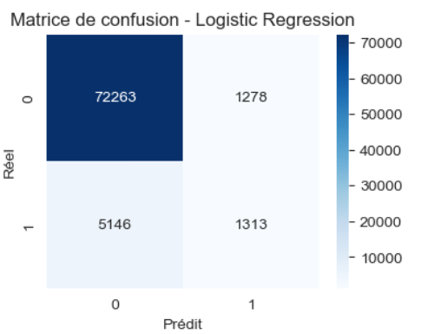
--- Random Forest ---
Accuracy : 0.9212
ROC-AUC : 0.8910

Classification Report :
precision recall f1-score support

0 0.92 1.00 0.96 73541
1 0.63 0.06 0.11 6459

accuracy 0.92 80000
macro avg 0.77 0.53 0.53 80000
weighted avg 0.90 0.92 0.89 80000
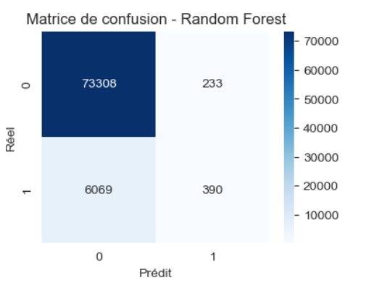
--- Gradient Boosting ---
Accuracy : 0.9222
ROC-AUC : 0.8987

Classification Report :
precision recall f1-score support

0 0.93 1.00 0.96 73541
1 0.64 0.08 0.14 6459

accuracy 0.92 80000
macro avg 0.78 0.54 0.55 80000
weighted avg 0.90 0.92 0.89 80000
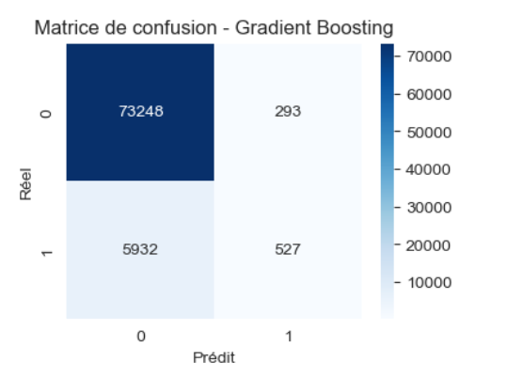
==================================================
RÉGRESSION - Prédiction des jours de retard
==================================================
Échantillon d'entraînement : 50000 lignes

--- Linear Regression ---
RMSE : 2.1586
R2 : -0.0002

--- Random Forest (50 trees, max_depth=10) ---
RMSE : 2.1605
R2 : -0.0020

--- Gradient Boosting (50 trees) ---
RMSE : 2.1590
R2 : -0.0006
==================================================
ANALYSE DES IMPORTANCES
==================================================
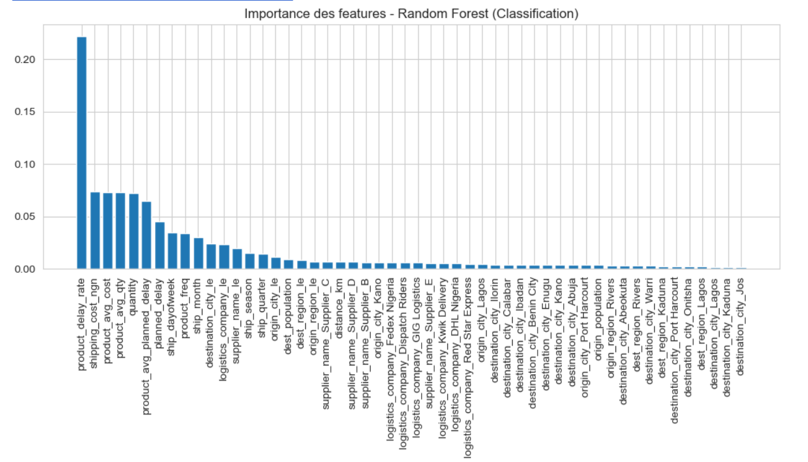
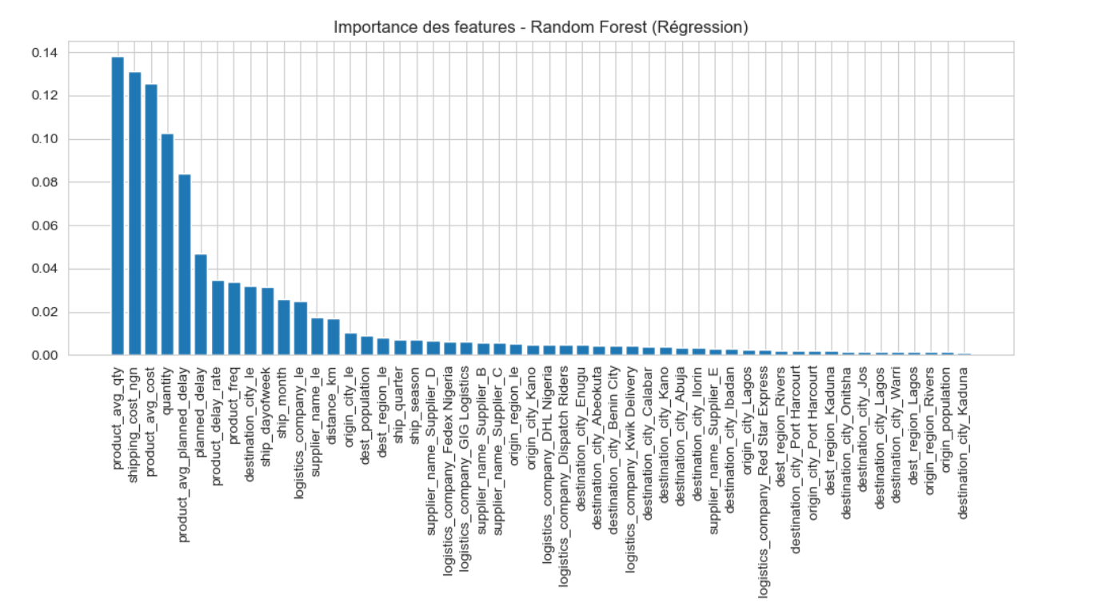
==================================================
INTERPRÉTATION ET RECOMMANDATIONS
==================================================

Les modèles Random Forest et Gradient Boosting montrent de bonnes performances.
Les variables les plus importantes (à ajuster selon votre sortie) incluent généralement :
- planned_delay : le délai prévu est un excellent prédicteur de retard.
- distance_km : les longues distances augmentent les risques.
- shipping_cost_ngn : les coûts élevés peuvent être associés à des expéditions prioritaires.
- product_avg_planned_delay : le comportement historique du produit est utile.
- logistics_company : certains prestataires sont plus fiables que d'autres.

Recommandations pour réduire les retards :
1. Optimiser les délais prévus en fonction des distances et des prestataires.
2. Identifier les prestataires les moins performants et renégocier ou remplacer.
3. Surveiller les produits avec des délais historiques longs.
4. Adapter les processus logistiques en fonction de la saisonnalité.
5. Utiliser le modèle pour prédire les retards avant expédition et ajuster les priorités.

